**HAGM System Requirements:**

1. STS 3.7.3
2. Spring 4.1.x
3. Hibernate 4.3.x
4. My Sql 5.1.x
5. JDK 1.8
6. Servlet 3.1
7. Maven 4
8. Pivotal tc Server Developer Edition 3.1 (Built in STS)

**This is how HAGM_app created:**

1. Download STS
2. Create a Maven Project

* File -> New -> Maven Project -> Select **spring-mvc-archetype.**

1. If you don’t see the **spring-mvc-archetype**, click the **Add Archetype…** button. In the *Add Archetype* dialog, type the following information:

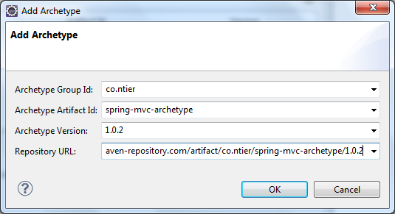

* + Archetype Group Id: **co.ntier**
  + Archetype Artifact Id: **spring-mvc-archetype**
  + Archetype Version: **1.0.2**
  + Repository URL: **http://maven-repository.com/artifact/co.ntier/spring-mvc-archetype/1.0.2**

Click **OK** and wait for a moment while STS is downloading the archetype. Finally you would see the **spring-mvc-archetype** in the list. Select it and click **Next**.

1. In the next screen, *Specify Archetype parameters*, enter the following information (for example):

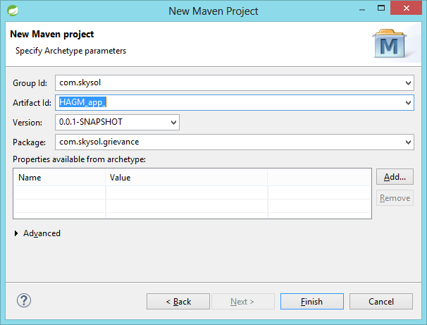

1. Click **Finish**.

**Configure HAGM_app in STS workspace:**

1. Clone HAGM_app from GIT
2. Use the below credentials to clone:

username: sridhar@skysolinc.com

password: sky1234

1. Open STS. Select File -> Import -> Maven -> Existing Maven Projrcts -> Browse to your local project directory -> Select pom.xml

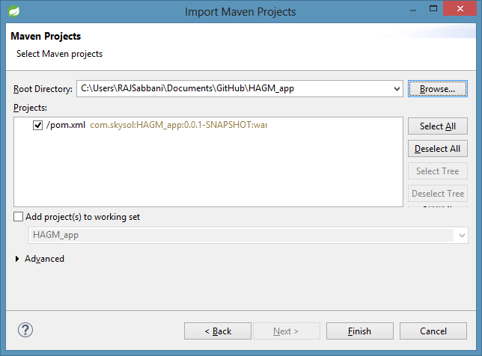

1. Click **Finish**.
2. Right click on HAGM_app project.
3. Select Run on Server -> Select Pivotal tc Server -> Click Next -> Click Finish.

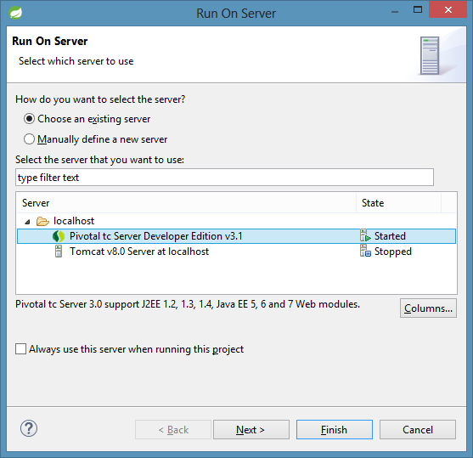

1. Now you can see the below login screen:

